STUDY HALL
CLASS VII
SCIENCE- FLOW OF HEAT
WORKSHEET- 5

- Study the picture given below and label 1-3:

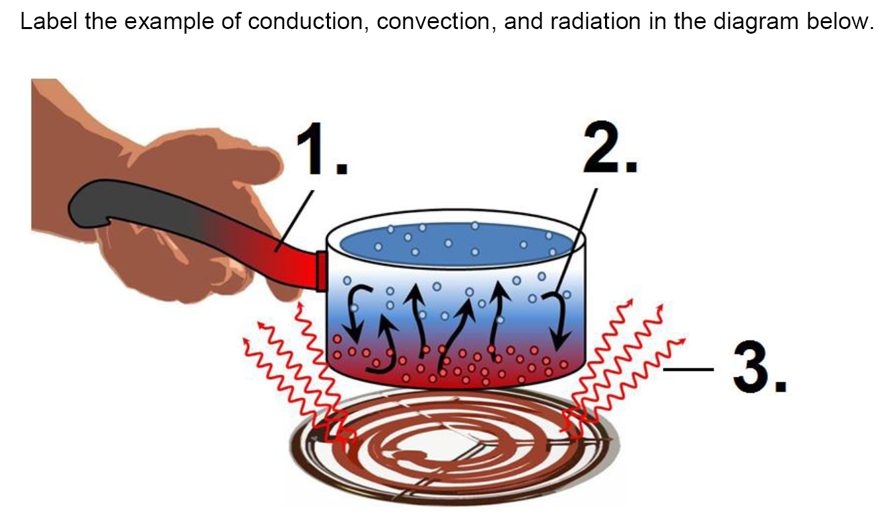
1-______________
2-______________
3-______________

- Penguins. Are one cuddling love among birds. Answer the following keeping them in mind:
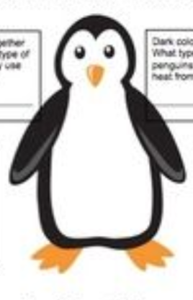
- Penguins huddle togetherto stay warm. What type of heat
transfer do they use when they do this??? _________
- Since it is so cold in Antarctica, penguins could easily lose all
their body heat to the environment and lead to death. Luckily,
they have feathers to keep them warm. What type of heat
transfer are the penguins saving themselves from using their
feathers? ____________
- Dark colours absorb heat. What type of heat transfer do
Penguins use when they absorb heat from the sun on their
back? ___________

- IDENTIFY THE THREE MODES OF HEAT TRANSFER IN THE FOLLOWING THREE PICTURES OF A COMIC STRIP.
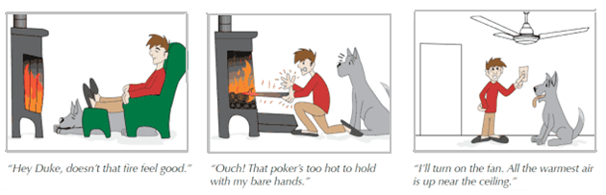

YES‼‼‼ IT IS RIGHT ‼‼

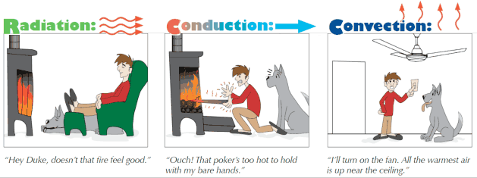

DRAW A SIMILAR COMIC STRIP USING ANY OF YOUR CREATIVE IMAGINATION TO DEPICT THE THREE MODES OF HEAT TRANSFER. Click a picture of it and copy it on your word file only and then submit. DO NOT SUBMIT IT AS A PICTURE ALONE OR MAKE A PDF OF IT.

